Outlook 2010 – How to backup all your mail, contacts, calendars and tasks.
The following instructions will walk you through the process of backing of all your current mail to a PST file that you will store on your local computer. These instructions are intended for users on Outlook 2010.
- Open Outlook
- Click on the FILE menu at the top of the screen
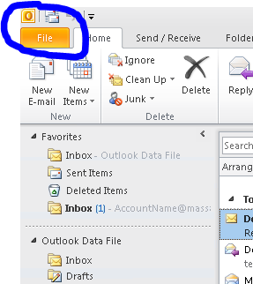
- Click on Open
- Click on Import and the Import & Export Wizard will appear
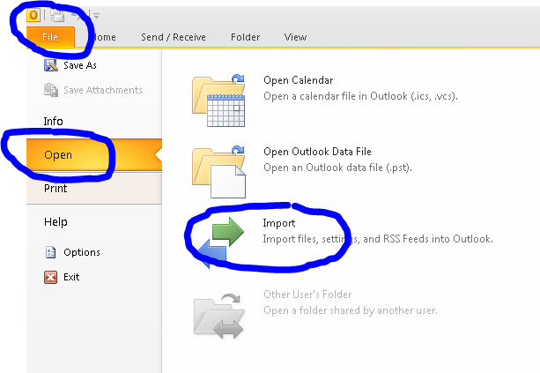
- Click on “Export to a file” from the list and then click on the NEXT button
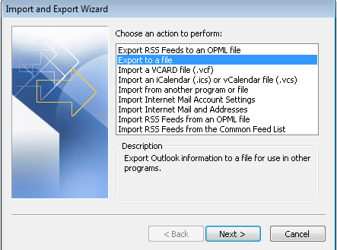
- Click on “Outlook Data File (.pst) from the list and then click NEXT
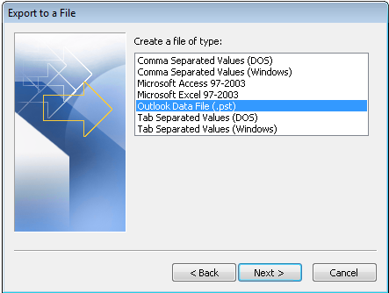
- Click on Outlook Data File to select it and make sure there is a Check Mark in the Include Subfolders box and then click NEXT
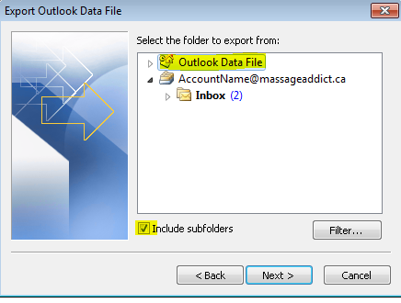

- In the “Save exported file as:” field, you can accept the defaults or specify a new location and file name. For the Options, you can leave it as is. Then click on FINISH
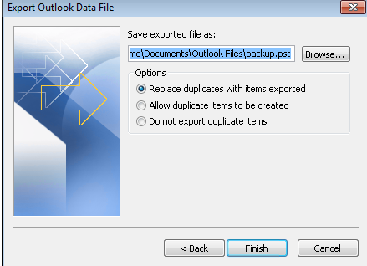
- The following window will appear asking you for an optional password. If you want to secure this file then enter a password, otherwise click OK to continue.
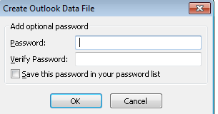

Outlook 2010 – How to add Office365 Account.
The following instructions will walk you through the process of adding your Office365 account to Outlook. These instructions are intended for users on Outlook 2010 only.
NOTE: Please make sure you have backed up your current Outlook data before proceeding!
- Open Outlook
- Click on the FILE menu at the top right side of the screen
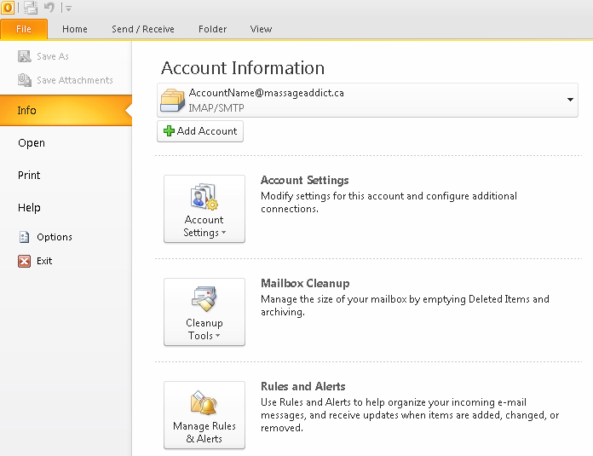
- Click on the button just below Account Information
- Enter the following information in the fields provided and click next. See Example screen shot below.
  - Your Name: First and Last Name
  - E-Mail Address: accountname@massageaddict.ca
NOTE: accountname should be your email name in front of @massageaddict.ca
  - Password: Enter your Office365 Password
  - Retype Password: Enter your Office365 Password again
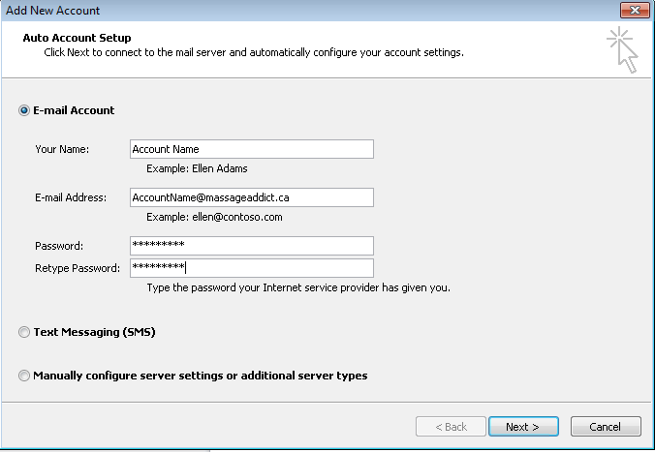
- Outlook will automatically lookup your information in Office365 and create your account. When this is complete, you can click on FINISH.
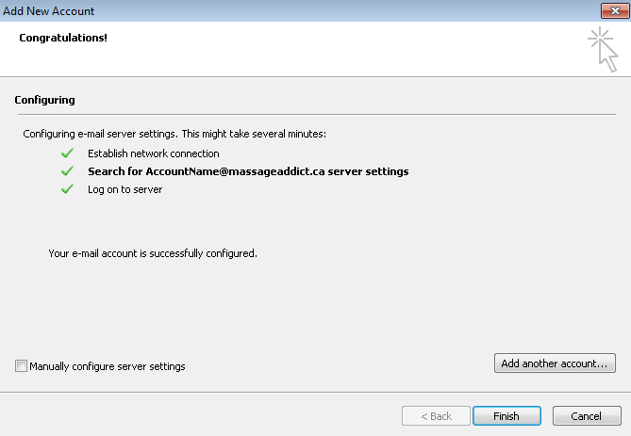
- After clicking FINISH, you will get the following prompt indicating to close and restart Outlook. Click on the OK button and then close Outlook and reopen it.
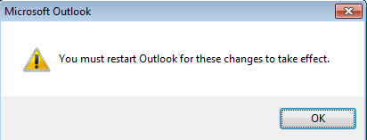
- After closing and reopening Outlook, you will be immediately prompted with your Office365 password. Enter your password and click on the check box “Remember my credentials”. Click OK to continue.
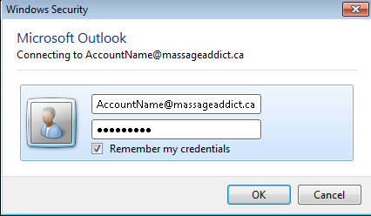

- NOTE: Outlook may take several seconds to open while it creates your new account. Once you login, you will see the following

Outlook 2010 – How to import Calendar/Contacts/Tasks.
The following instructions will walk you through the process of importing your Outlook Calendar, Contacts and/or Tasks that you previously backed up. These instructions are intended for users on Outlook 2010 only.

- Open Outlook
- Click on the FILE menu at the top of the screen
- Click on Open
- Click on Import and the Import & Export Wizard will appear
- The default “Import from another program or file” will be selected. Click NEXT
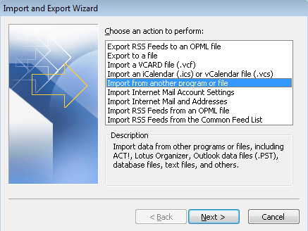
- On the Import a File window, click on “Outlook Data File (.pst) and click NEXT to continue.
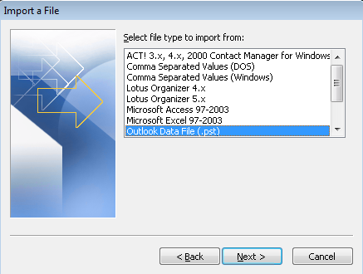

- For the file to Import either accept the default or click on the BROWSE button to locate the file you saved when you backed up your data. For Options, leave the default setting “Replace duplicates with items imported. Click NEXT to continue.
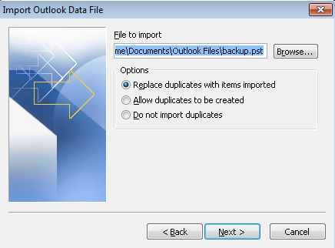
- In the following screen, click on the item (Calendar, Contacts, Tasks, etc) under the Outlook Data File that you want to import. Leave the other settings as shown below and click FINISH.
NOTE: The example below has Contacts selected
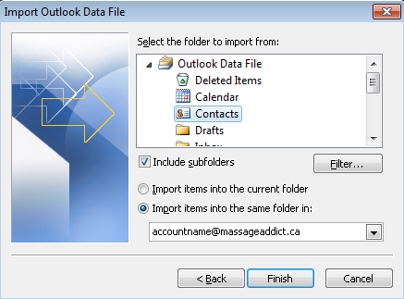
- Repeat Steps 2-8 to import any other folder into your Office365 account.

